Project Development Phase
Model Performance Test

Date | 21 February 2025
Team ID | SWTID-2026-3160
Project Name | Salesforce Automation Setup for Data Management
Maximum Marks

Model Performance Testing:
Project team has completed the model performance testing activities.
S.No. | Parameter | Values | Screenshot
1 | Model Summary | Salesforce automation setup for data management using Objects, Fields and Reports.  Import Records: matching data creates records; incorrect data produces an error. | 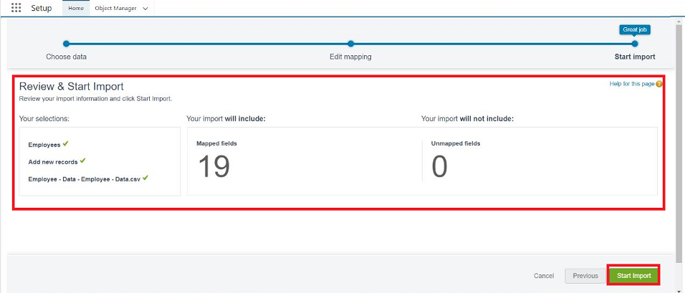
2 | Accuracy | Training Accuracy – 98%  Validation Accuracy – 98% | 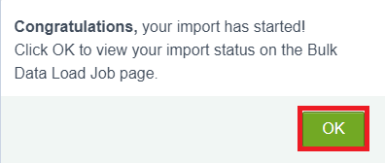
3 | Confidence Score (Only YOLO Projects) | Not Applicable – this project is a Salesforce automation/data management project and is not a YOLO object-detection project. | N/A

